User Guide

Background:
Do you want to stay healthy, but you don’t know where to start? Do you want to take off those extra pounds that you’ve put on over the years, but you can’t manage to do it? We’ve got good news. KPDailyCheckup is here to help you!

Kaiser Permanente’s new preventative health app is here to help you be healthy and happy. Whether you want to get in shape, reduce your risk of chronic disease or manage a condition you already have, we can help you achieve your health goals.

Details:
Scroll to the next pages to view this section.

Log into the app:

Open the app and you will see the Login page:
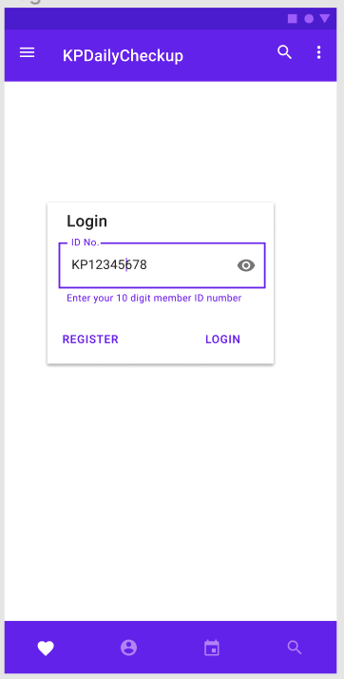  Enter your Member ID in the box and press LOGIN. If you have not yet signed up for the app, click REGISTER and follow the prompts. (See separate instructions.) | 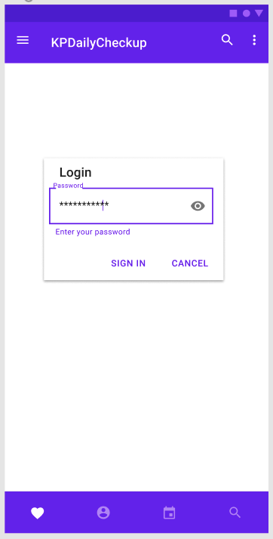  Enter your password in the box, then click SIGN IN.

How to view your Daily Log:

You can view the meals and activity that you’ve logged today in the Daily Log. Open the menu by clicking on the three bars on the top left side of the screen.
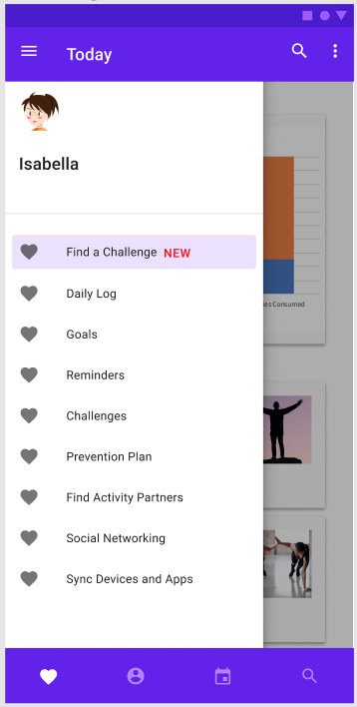  Select ‘Daily Log’ from the menu. (Circled above). | 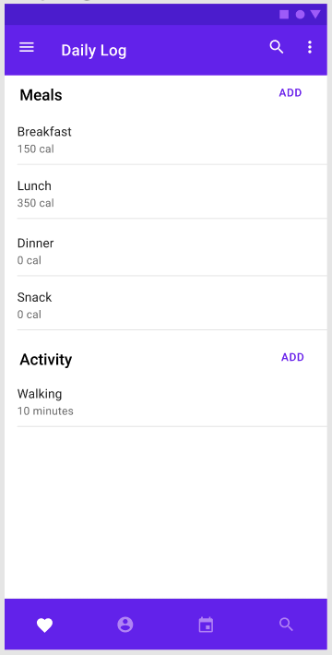  You will be taken to your Daily Log where you can see the meals and activity you’ve logged and with their corresponding calories.  You can log additional meals and activity by clicking on the ADD buttons in either the Meals or Activity sections.

